**Introduction to ADAM9, Physiological Roles, and Significance in Disease Development**

The **A** **D**isintegrin **A**nd **M**etalloprotease (ADAM) gene group encode proteins with proteolytic and adhesive functional implications in tumorigenesis, neurogenesis, and development of diverse human diseases (Giebeler & Zigrino, 2016; Oria et al., 2018; Micocci et al., 2013).

* Introduce both the non-catalytic and catalytically active ADAMs as well as broadly mentioning a few of their roles.
* Then proceed to the catalytic group of which ADAM9 is part of. Briefly describe the roles of these catalytic ADAMs in physiological and pathological conditions including cancer.
* Finish this paragraph with the specific role of ADAM9 in pathological conditions including cancer, Alzheimer, retinopathy etc
* Since our goal is to look at Liver, Pancreas, Cervix, and Bladder Cancers, are there any studies between ADAM9 expression and these tumors out there (Search PubMed). Summarize their main findings (angiogenesis, metastasis, tumor growth etc). Look at the signalling pathways implicated/ substrates involved/integrins??
* Did any of these studies use TCGA data? Why is TCGA data important? This is the gap we are trying to exploit and will be the basis of our study

Besides ADAM 9, about 20 other human ADAM genes have been presently found significant in diverse cellular roles, including ectodomain shedding and integrin interactions functions implicated in many signalling pathways (Souza et al., 2020; Oria et al., 2018; Micocci et al., 2013). Typical ADAM9 substrates include HB-EGF-like growth factors among other membrane-anchored proteins such as receptors (Weber & Saftig, 2012). ADAM9 genes are expressed ubiquitously in somatic tissues including cells in the brain, heart, muscle, prostate, placenta, lymph node, bone marrow, retina, skin, breast, and lungs (Oria et al., 2018; Bazzone et al., 2019: Roychaudhuri et al., 2014). During synthesis, a 110kDa ADAM9-precursor protein is modified by furin into a functional 84-kDa cysteine-rich protein (Zhou et al., 2020).

~~Located on chromosome 8, the 2460 nucleotides long human ADAM9 gene encodes 819 amino acid residues. Protein translation and alternative splicing of mRNA transcripts result in full-length transmembrane (ADAM9-L) and secreted isoform 2 (ADAM9-S) (Goldstein et al., 2010; Fry et al., 2010; Mazzocca et al., 2005). Besides other functional domains, ADAM9 has a single hydrophobic end and an N-terminal signal peptide sequence region important in secretory pathways (Figure 1).~~

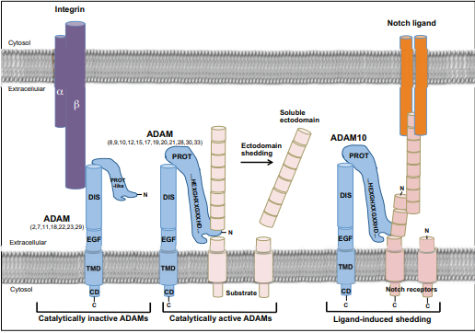

*Figure 1: Structure of ADAM Proteins.* The diagrams demonstrate the general ADAM protein structure, non-proteolytic interaction with integrins, and involvement in functions such as notch signalling.

~~The molecular cascade implicating ADAM9 in metastatic and disease development mechanisms commences with the activation of pro-ADAMS (Figure 2).~~ External protein signals then activate ectodomain shedding mediated by diverse signals, including MAPK and PKC pathways leading to processing of cellular proteins and their receptors with implications in tumor stromal cells crosstalks including cell motility and trafficking (Weber & Saftig, 2012).

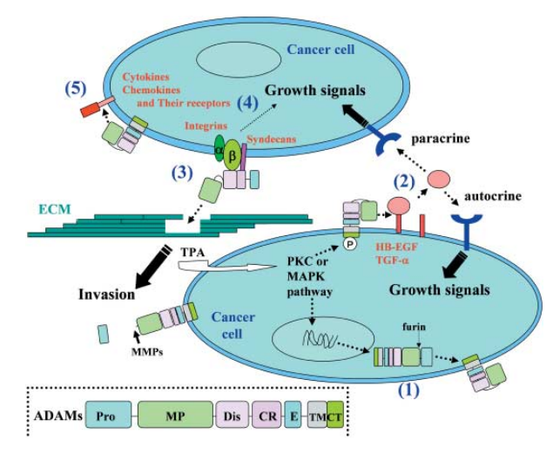

Figure 2: *Molecular Cascade of ADAMS Role in Tumor Biology.* As illustrated, functional domains of ADAMS initiate cellular crosstalks through membrane-anchored proteins creating a network of intracellular and extracellular messages (Mochizuki & Okada, 2007). Some of these signals are reported in lymph vascularization of several metastatic cancers, including PDAC (Oria et al., 2018).

ADAM proteins are significant*ly* reported in the development of many disease*s* including neoplastic disorders, viral diseases, epilepsy, body starvation, renal diseases, Pulmonary complications, Inflammatory polymyositis and myositis, cancers, tissue injury (Lungs), atherosclerosis, neurodegenerative disorders, and cancers(Oria et al., 2018*;* Tousseyn et al.*,* 2009*;* (Oria et al., 2019; Kossmann et al., 2017; Fritzsche et al., 2008; Mazzocca et al., 2005; Micocci et al., 2013; Lin et al., 2017; Tanasubsinn et al., 2017). High ADAM9 expression has been linked to poor prognosis and shortened overall survival different solid tumors [Cite all those studies here]. Then proceed to select 3 to 4 studies and summarize their main findings. For example, Oria et al., 2018 found out that high ADAM9 expression in PDAC tumors promotes angiogenesis via HB-EGF signalling *in vitro*. This resulted was validated *in vivo* where decreased ADAM9 expression was associated with reduced blood vessel formation. Choose another 3 studies and summarize their findings like this. In clinical assessment of most tumors, overexpression of ADAM9 is linked to poor clinical outcomes, including reduced overall survival rates and cancer development. For instance, the increased expression of ADAM9 by pancreatic ductal adenocarcinoma (PDAC) cells is correlated with poor tumor grading and vasculature invasion (Oria et al., 2019). ~~Also,~~ Mazzocca et al. (2005) and Kossmann et al. (2017) found that tumor-stromal interactions with ADAM9 are significant in cancer metastasis and a contributor to poor prognosis in liver cancers and lung adenocarcinomas respectively. In renal cell cancers, Fritzsche et al. (2005) links the increased expression of ADAM9 with poor prognosis, decreased victims' survival rates, distant metastasis, positive nodal status, and higher tumor grade. Micocci et al. (2013) study using RNAi-mediated ADAM9 silenced MDA-MB-231 cells reported that activated Hematopoietic stem cells (HSCs) secrete ADAM9-S, which regulates tumor cell invasion and metastasis through tumor-stromal interactions. Lin et al. (2017) demonstrated ADAM9 influence in lung cancer cells vascular remodeling leading to brain metastasis, angiogenesis, and poor clinical prognosis. Further, protein and gene expression investigations in squamous cell carcinoma correlated ADAM9 expression with cellular differentiation and cancer pathogenesis (Tanasubsinn et al., 2017; Wang et al., 2019). In encephalopathies studies involving pathogenic prions, Tousseyn et al. (2009), elucidated the catalytic potential of ADAM9 in shedding ADAM10 with potential gene regulation and protein signaling functions. [Great paragraph documenting studies that have implicated ADAM9 in tumor progression.]

The polyvalence of ADAM9 is involved in disintegrin domain interactions with α6β1 integrin in fibroblasts, αVβ5 in myeloma cells, and αVβ3 in MDA-MB-231 breast tumor cells with significance in specified tumor metastasis (Nath et al., 2000; Mahimkar et al., 2005; Bazzone et al., 2019; Przemyslaw et al., 2013; Zigrino et al., 2007). For instance, Bazzone et al. (2019) used CRISPR genetic screening to identify virus-interaction genes and found ADAM9 sgRNAs as a top candidate for EMCV-induced cell death and viral replication. The EMCV is a known model virus with mechanistic roles in innate immunity, which infers the involvement of ADAM9 in Fibroblast growth factors (FGF) signaling pathway, a crucial physiological process regulating tissue development.

One of the reported positive physiological roles of ADAM9 is in the pathology of Alzheimer's disease (AD). Typically, β and γ-secretases degrade APP leading to the accumulation of β-amyloid (Aβ), which causes AD. However, ADAM9, 10, and 17 functions as α-secretases cleaving the Aβ domain of APP hence preventing the production of Aβ peptides (Manzine et al., 2019; Eren et al., 2019; Cong & Jia, 2011).

References

Bazzone, L. E., King, M., MacKay, C. R., Kyawe, P. P., Meraner, P., Lindstrom, D., ... & Kurt-Jones, E. A. (2019). A disintegrin and metalloproteinase 9 domain (ADAM9) Is a major susceptibility factor in the early stages of encephalomyocarditis virus infection. *Mbio*, 10(1).

Cong, L., & Jia, J. (2011). Promoter polymorphisms which regulate ADAM9 transcription are protective against sporadic Alzheimer's disease. Neurobiology of aging, 32(1), 54-62.

Eren, F., Inanır, N. T., Fedakar, R……, Aynekin. B & Demircan, Kadir. (2019). Importance of β-APP, ADAM9, 10, 17 in Alzheimer Disease: Preliminary Autopsy Study with Immunohistochemical Expression in Human Brain. *International Journal of Medical Research & Health Sciences*, 2019, 8(7): 68-73

Fritzsche, F. R., Wassermann, K., Jung, M., Tölle, A., Kristiansen, I., Lein, M., ... & Kristiansen, G. (2008). ADAM9 is highly expressed in renal cell cancer and is associated with tumour progression. BMC cancer, 8(1), 179.

Fry, J. L., & Toker, A. (2010). Secreted and membrane-bound isoforms of protease ADAM9 have opposing effects on breast cancer cell migration. *Cancer research*, 70(20), 8187-8198.

Giebeler, N., & Zigrino, P. (2016). A disintegrin and metalloprotease (ADAM): historical overview of their functions. *Toxins*, 8(4), 122.

Goldstein, O., Mezey, J. G., Boyko, A. R., Gao, C., Wang, W., Bustamante, C. D., ... & Acland, G. M. (2010). An ADAM9 mutation in canine cone-rod dystrophy 3 establishes homology with human cone-rod dystrophy 9. *Molecular vision*, 16, 1549.

Kossmann, C. M., Annereau, M., Thomas-Schoemann, A., Nicco-Overney, C., Chéreau, C., Batteux, F., ... & Lemare, F. (2017). ADAM9 expression promotes an aggressive lung adenocarcinoma phenotype. Tumor Biology, 39(7), 1010428317716077.

Lin, C. Y., Cho, C. F., Bai, S. T., Liu, J. P., Kuo, T. T., Wang, L. J., ... & Hsieh, C. Y. (2017). ADAM9 promotes lung cancer progression through vascular remodeling by VEGFA, ANGPT2, and PLAT. Scientific reports, 7(1), 1-13.

Mahimkar, R. M., Visaya, O., Pollock, A. S., & Lovett, D. H. (2005). The disintegrin domain of ADAM9: a ligand for multiple β1 renal integrins. *Biochemical Journal*, 385(2), 461-468.

Manzine, P. R., Ettcheto, M., Cano, A., Busquets, O., Marcello, E., Pelucchi, S., ... & Cominetti, M. R. (2019). ADAM10 in Alzheimer's disease: Pharmacological modulation by natural compounds and its role as a peripheral marker. Biomedicine & Pharmacotherapy, 113, 108661.

Mazzocca, A., Coppari, R., De Franco, R., Cho, J. Y., Libermann, T. A., Pinzani, M., & Toker, A. (2005). A secreted form of ADAM9 promotes carcinoma invasion through tumor-stromal interactions. *Cancer research*, 65(11), 4728-4738.

Micocci, K. C., Martin, A. C. B. M., de Freitas Montenegro, C., Durante, A. C., Pouliot, N., Cominetti, M. R., & Selistre-de-Araujo, H. S. (2013). ADAM9 silencing inhibits breast tumor cell invasion in vitro. *Biochimie*, 95(7), 1371-1378.

Mochizuki, S., & Okada, Y. (2007). ADAMs in cancer cell proliferation and progression. *Cancer science*, 98(5), 621-628.

Nath, D., Slocombe, P. M., Webster, A., Stephens, P. E., Docherty, A. J., & Murphy, G. (2000). Meltrin gamma (ADAM-9) mediates cellular adhesion through alpha (6) beta (1) integrin, leading to a marked induction of fibroblast cell motility. Journal of cell science, 113(12), 2319-2328.

Oria, V. O., Lopatta, P., & Schilling, O. (2018). The pleiotropic roles of ADAM9 in the biology of solid tumors. *Cellular and Molecular Life Sciences*, 75(13), 2291-2301.

Oria, V. O., Lopatta, P., Schmitz, T., Preca, B. T., Nyström, A., Conrad, C., ... & Bronsert, P. (2019). ADAM 9 contributes to vascular invasion in pancreatic ductal adenocarcinoma. Molecular oncology, 13(2), 456-479.

Przemyslaw, L., Boguslaw, H. A., Elzbieta, S., & Malgorzata, S. M. (2013). ADAM and ADAMTS family proteins and their role in the colorectal cancer etiopathogenesis. *BMB reports*, 46(3), 139.

Roychaudhuri, R., Hergrueter, A. H., Polverino, F., Laucho-Contreras, M. E., Gupta, K., Borregaard, N., & Owen, C. A. (2014). ADAM9 is a novel product of polymorphonuclear neutrophils: regulation of expression and contributions to extracellular matrix protein degradation during acute lung injury. *Journal of immunology (Baltimore, Md.: 1950)*, 193(5), 2469–2482. https://doi.org/10.4049/jimmunol.1303370

Souza, J. S. M., Lisboa, A. B. P., Santos, T. M., Andrade, M. V. S., Neves, V. B. S., Teles-Souza, J., ... & Del-Bem, L. E. (2020). The evolution of ADAM gene family in eukaryotes. *Genomics*.

Tanasubsinn, P., Aung, W. P. P., Pata, S., Laopajon, W., Makeudom, A., Sastraruji, T., ... & Krisanaprakornkit, S. (2018). Overexpression of ADAM9 in oral squamous cell carcinoma. Oncology letters, 15(1), 495-502.

Tousseyn, T., Thathiah, A., Jorissen, E., Raemaekers, T., Konietzko, U., Reiss, K., ... & Annaert, W. (2009). ADAM10, the rate-limiting protease of regulated intramembrane proteolysis of Notch and other proteins, is processed by ADAMS-9, ADAMS-15, and the γ-secretase. Journal of Biological Chemistry, 284(17), 11738-11747.

Wang, L., Chen, W., Zha, J., Yan, Y., Wei, Y., Chen, X., ... & Ge, L. (2019). miR‑543 acts as a novel oncogene in oral squamous cell carcinoma by targeting CYP3A5. Oncology reports, 42(3), 973-990.

Weber, S., & Saftig, P. (2012). Ectodomain shedding and ADAMs in development. *Development*, 139(20), 3693-3709.

Zhou, R., Cho, W., Ma, V., Cheuk, W., So, Y., & Wong, S. et al. (2020). ADAM9 Mediates Triple-Negative Breast Cancer Progression via AKT/NF-κB Pathway. *Frontiers In Medicine,* 7. doi: 10.3389/fmed.2020.00214

Zigrino, P., Steiger, J., Fox, J. W., Löffek, S., Schild, A., Nischt, R., & Mauch, C. (2007). Role of ADAM-9 disintegrin-cysteine-rich domains in human keratinocyte migration. *Journal of Biological Chemistry*, 282(42), 30785-30793.